Visualization -2 (Question-2)



Who’s Committing Suicide???

The World Health Organization (WHO) estimates that each year approximately one **million** people die from suicide, which represents a global **mortality** rate of 16 people per 100,000 or one **death** every 40 seconds. It is predicted that by 2020 the rate of **death** will increase to one every 20 seconds.

And this is a very serious problem these days, So I decided to take a look into this matter and visualize the suicides happening around the world to answer the most obvious questions like which countries are more vulnerable to this and what is the age group who commits maximum suicide and many more.

I downloaded the suicides dataset from World Health organization website.

Link [: https://www.who.int/mental_health/suicide-prevention/en](https://www.who.int/mental_health/suicide-prevention/en/)

Let’s investigate some facts about the dataset:

The dataset has 43776 rows and 6 columns

Columns:

Country year: 1979-2016

Sex: M/F

Age: Age group

Suicides no: Number of suicides

Population: Number of all living people

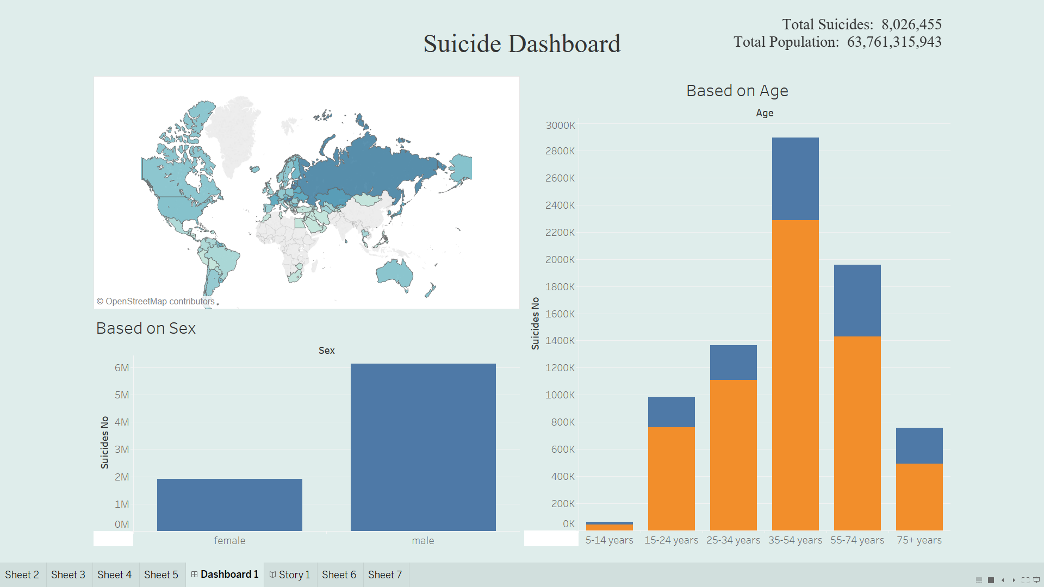

Do you have any idea about the suicide rate in your country?

I don’t think so let’s have a look:

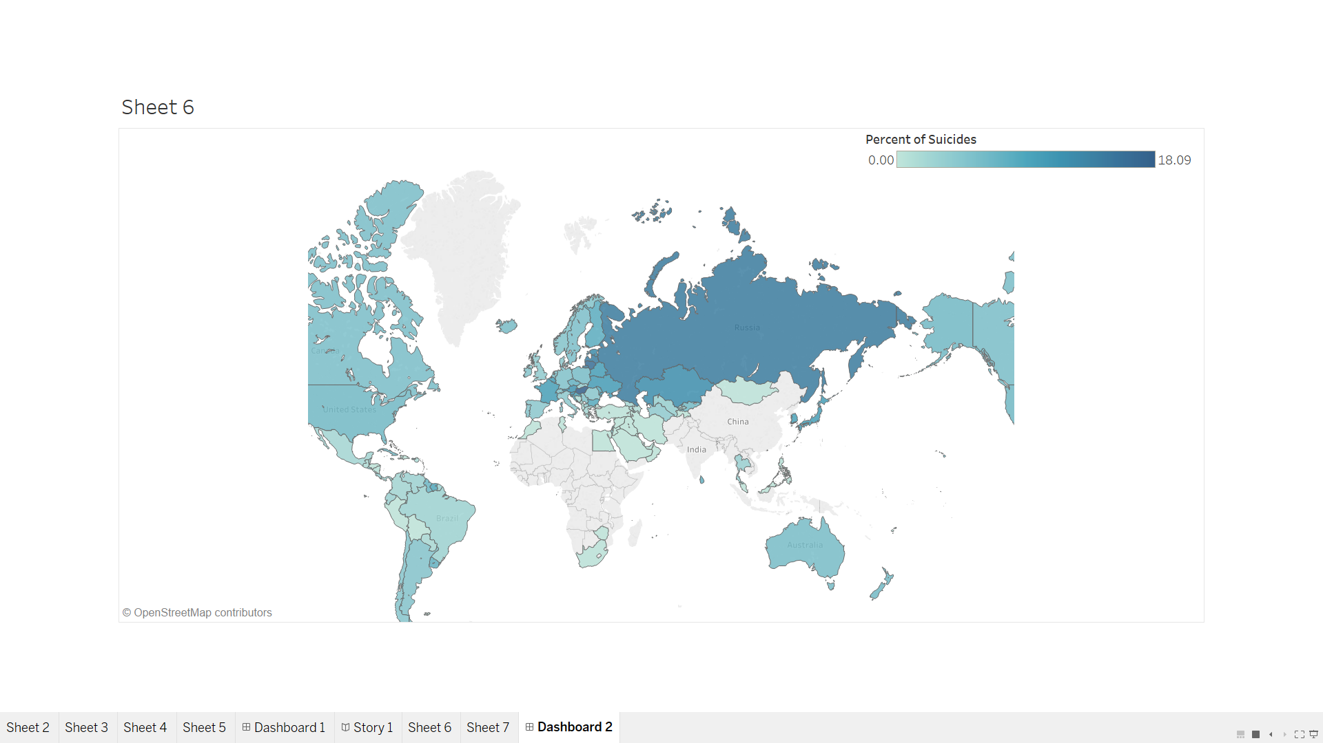

From the interactive graph above we can see the major countries in which suicide is a big problem are Russia, Kazakhstan, Ukraine. Mainly those countries are in Asia. So, we can say that the suicides are taking place more on east side of the world. But this analysis is also taking in consideration the data from 1978.

At that time many countries were poor and were struggling to meet the basic needs of its people. They were unstable at that time. May be that’s why we can see this trend. It can be different for recent years. Now countries are more stable and are developing fast.

Let’s see which Gender is more prone to suicide:

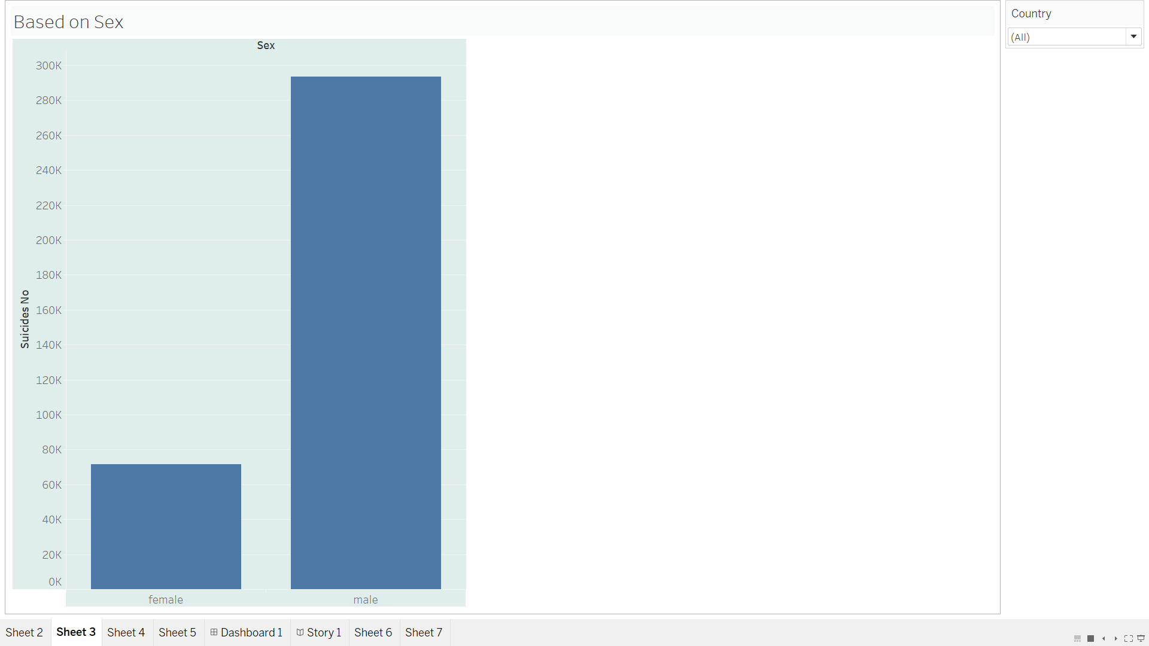

When taken into consideration all the suicides happening around the world irrespective of the country and the year we found out that male’s are more prone to suicides rather than females.

That’s mainly due to two things: “One is that men use more lethal means [to attempt suicide], and the second is that they don’t seek care as much,” says Simon Hatcher, vice-chair of research for the Department of Psychiatry at the University of Ottawa.

Men are more likely to use firearms and other deadly methods, while women are more likely to use pills. These differences might be because men are more comfortable with guns. Or it might be that, as some researchers have suggested, they’re choosing more extreme methods because they’re more suicidal in the first place.

We don’t know the main reason, but now we know that men are vulnerable to suicides.

Which is a big problem these days…...

Let’s check the Age Group which shows the most suicidal behavior:

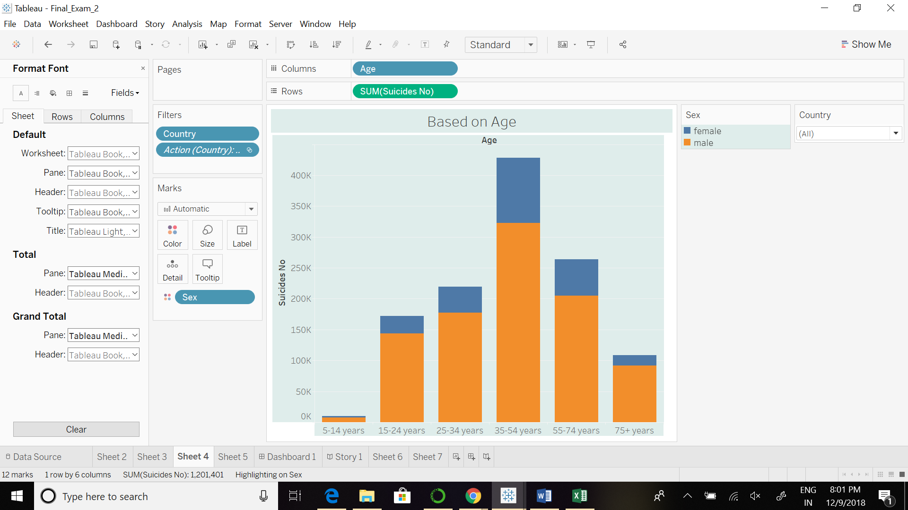

Form the graph above we can see that the age group with the maximum number of suicides is 35-54 years. People in this group are more likely to commit suicide than people in other age group.

[The Office for National Statistics (ONS) released its annual summary](https://www.ons.gov.uk/peoplepopulationandcommunity/birthsdeathsandmarriages/deaths/bulletins/suicidesintheunitedkingdom/2016registration) of data on deaths by suicide in the UK recently – in the run-up to [World Suicide Prevention Day](https://iasp.info/wspd2017/) – and the data shows that in 2016 people aged between 40 and 44 had the highest prevalence of suicide, a rate of 15.1 deaths per 100,000 people. Split by gender, the highest prevalence was for men aged 40 to 44 (23.7 deaths per 100,000 in 2016) and women between the ages 50 and 54 (6.4 deaths per 100,000 in 2016).

This might be because of too much work stress or may be some other reason but people in this group are in serious trouble. They might be experiencing more pressure and they are unable to handle it. There should be proper Centers for mind relaxing camps and counselling should be provided to people in these age Group.

Let’s Compare Countries and see what is the suicide trend in recent years….

Let’s compare two developed nations say Russia and USA.

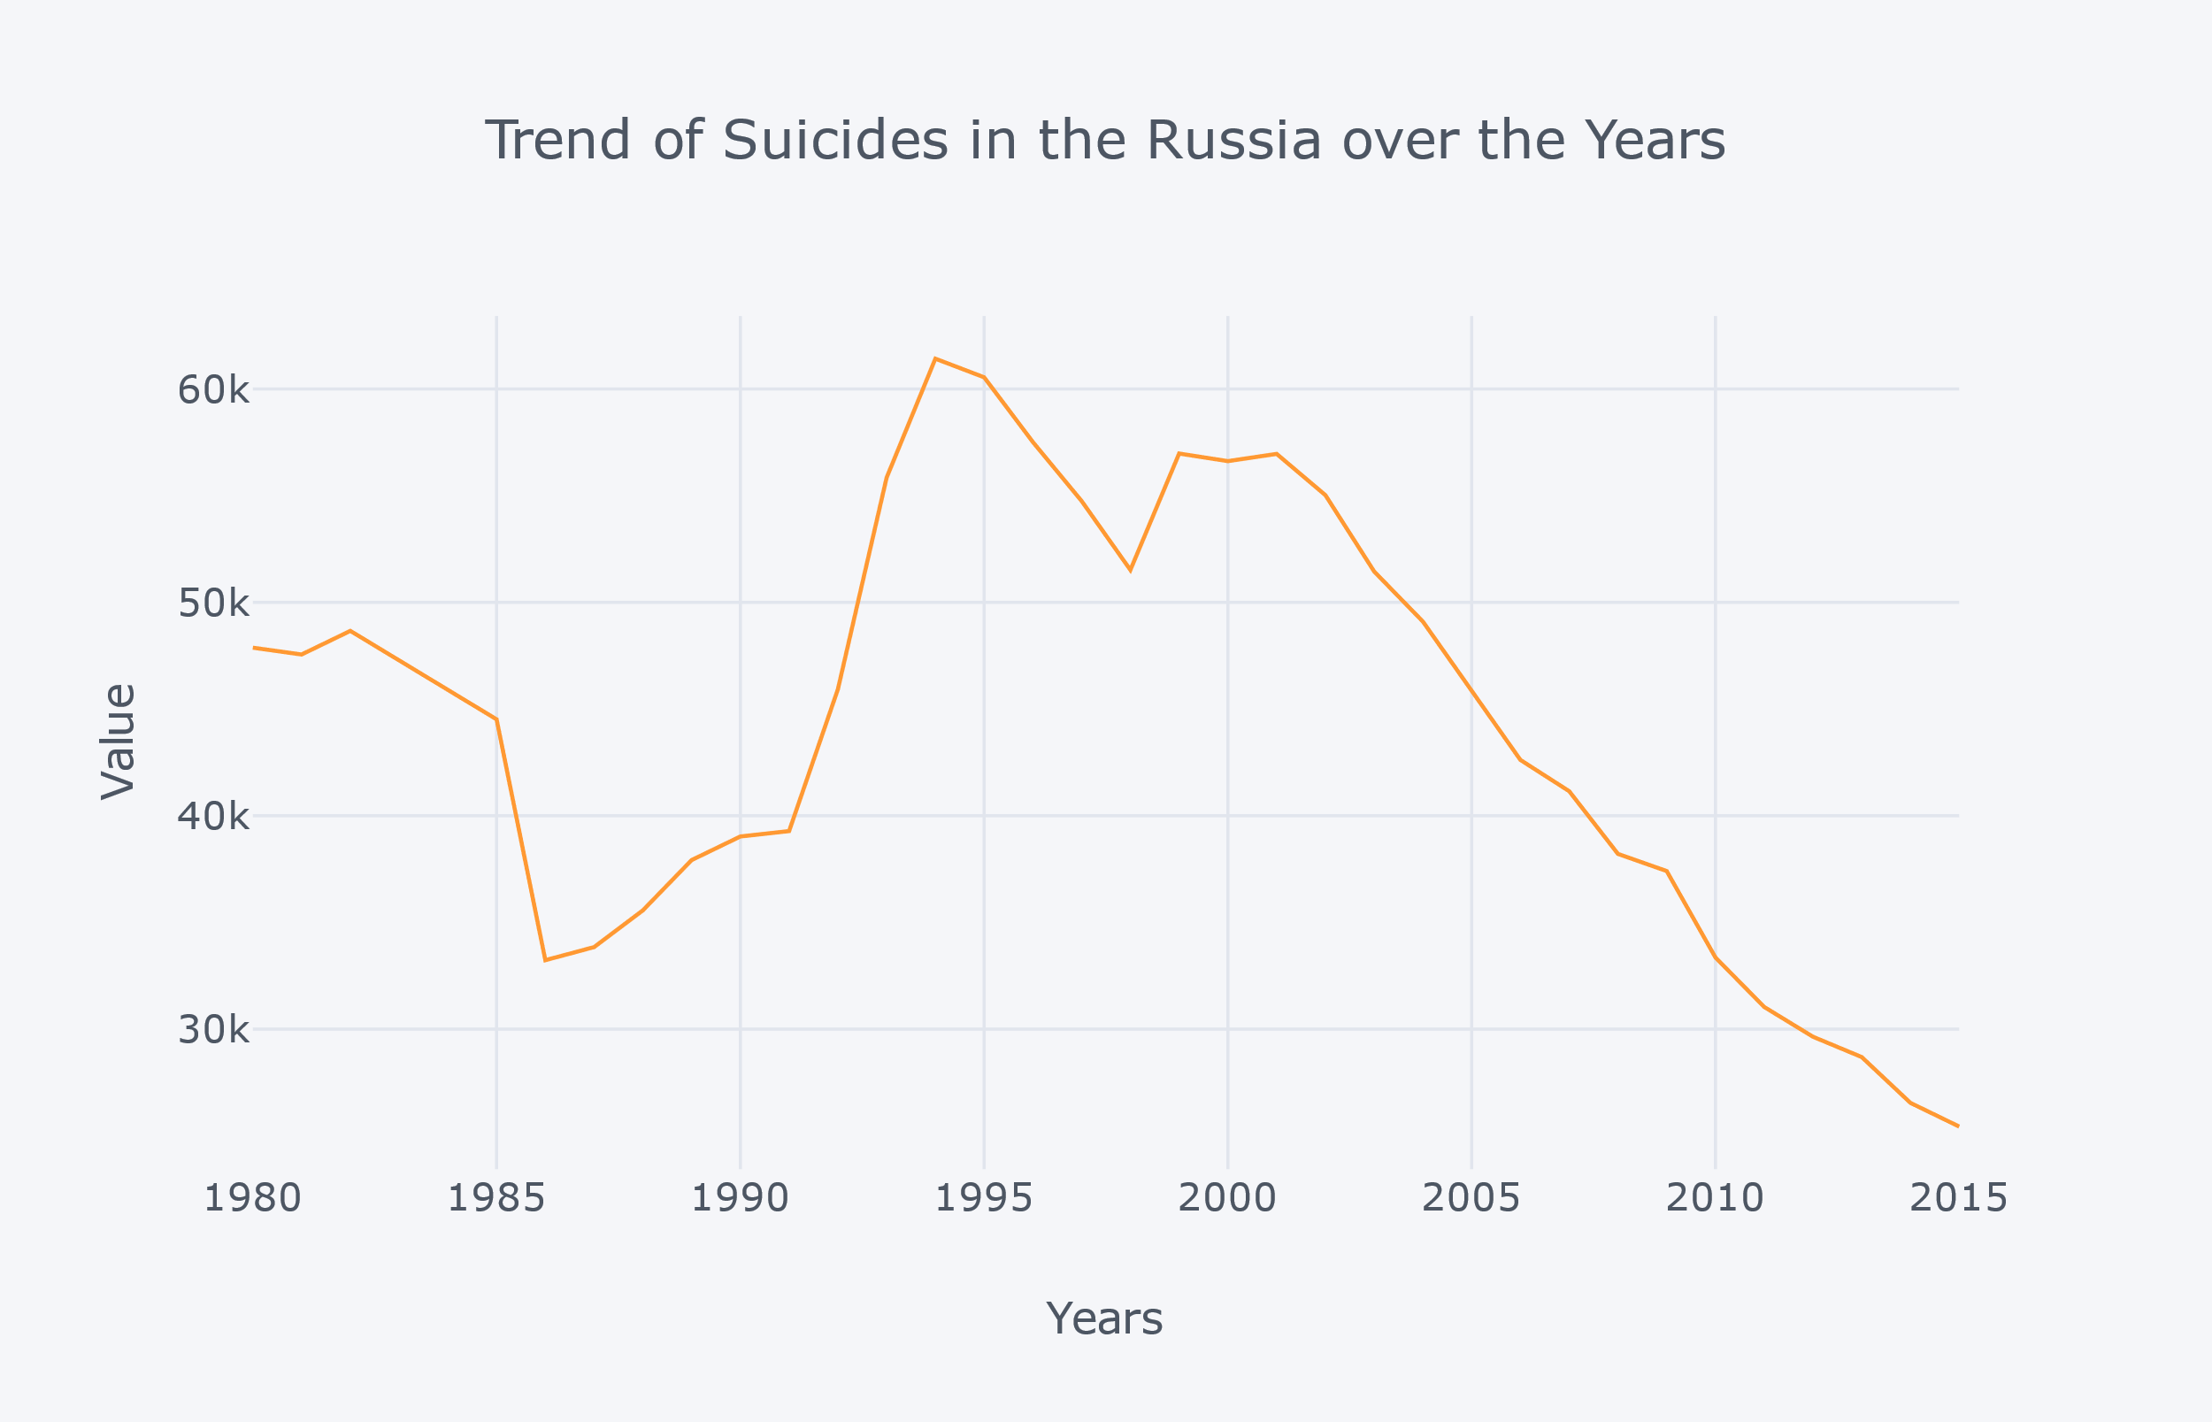

We can see from the graph that the Suicide rate was high in early 90’s in Russia and it was at peak around 1994-1995 but after that Russia controlled it and has taken good measures to bring it down now it is at its minimum in 2015. The government has really done well in securing the lives of its people. But still it is on the top of the list mainly because of alcohol culture and increase in the purchase of firearms in some regions of Russia.

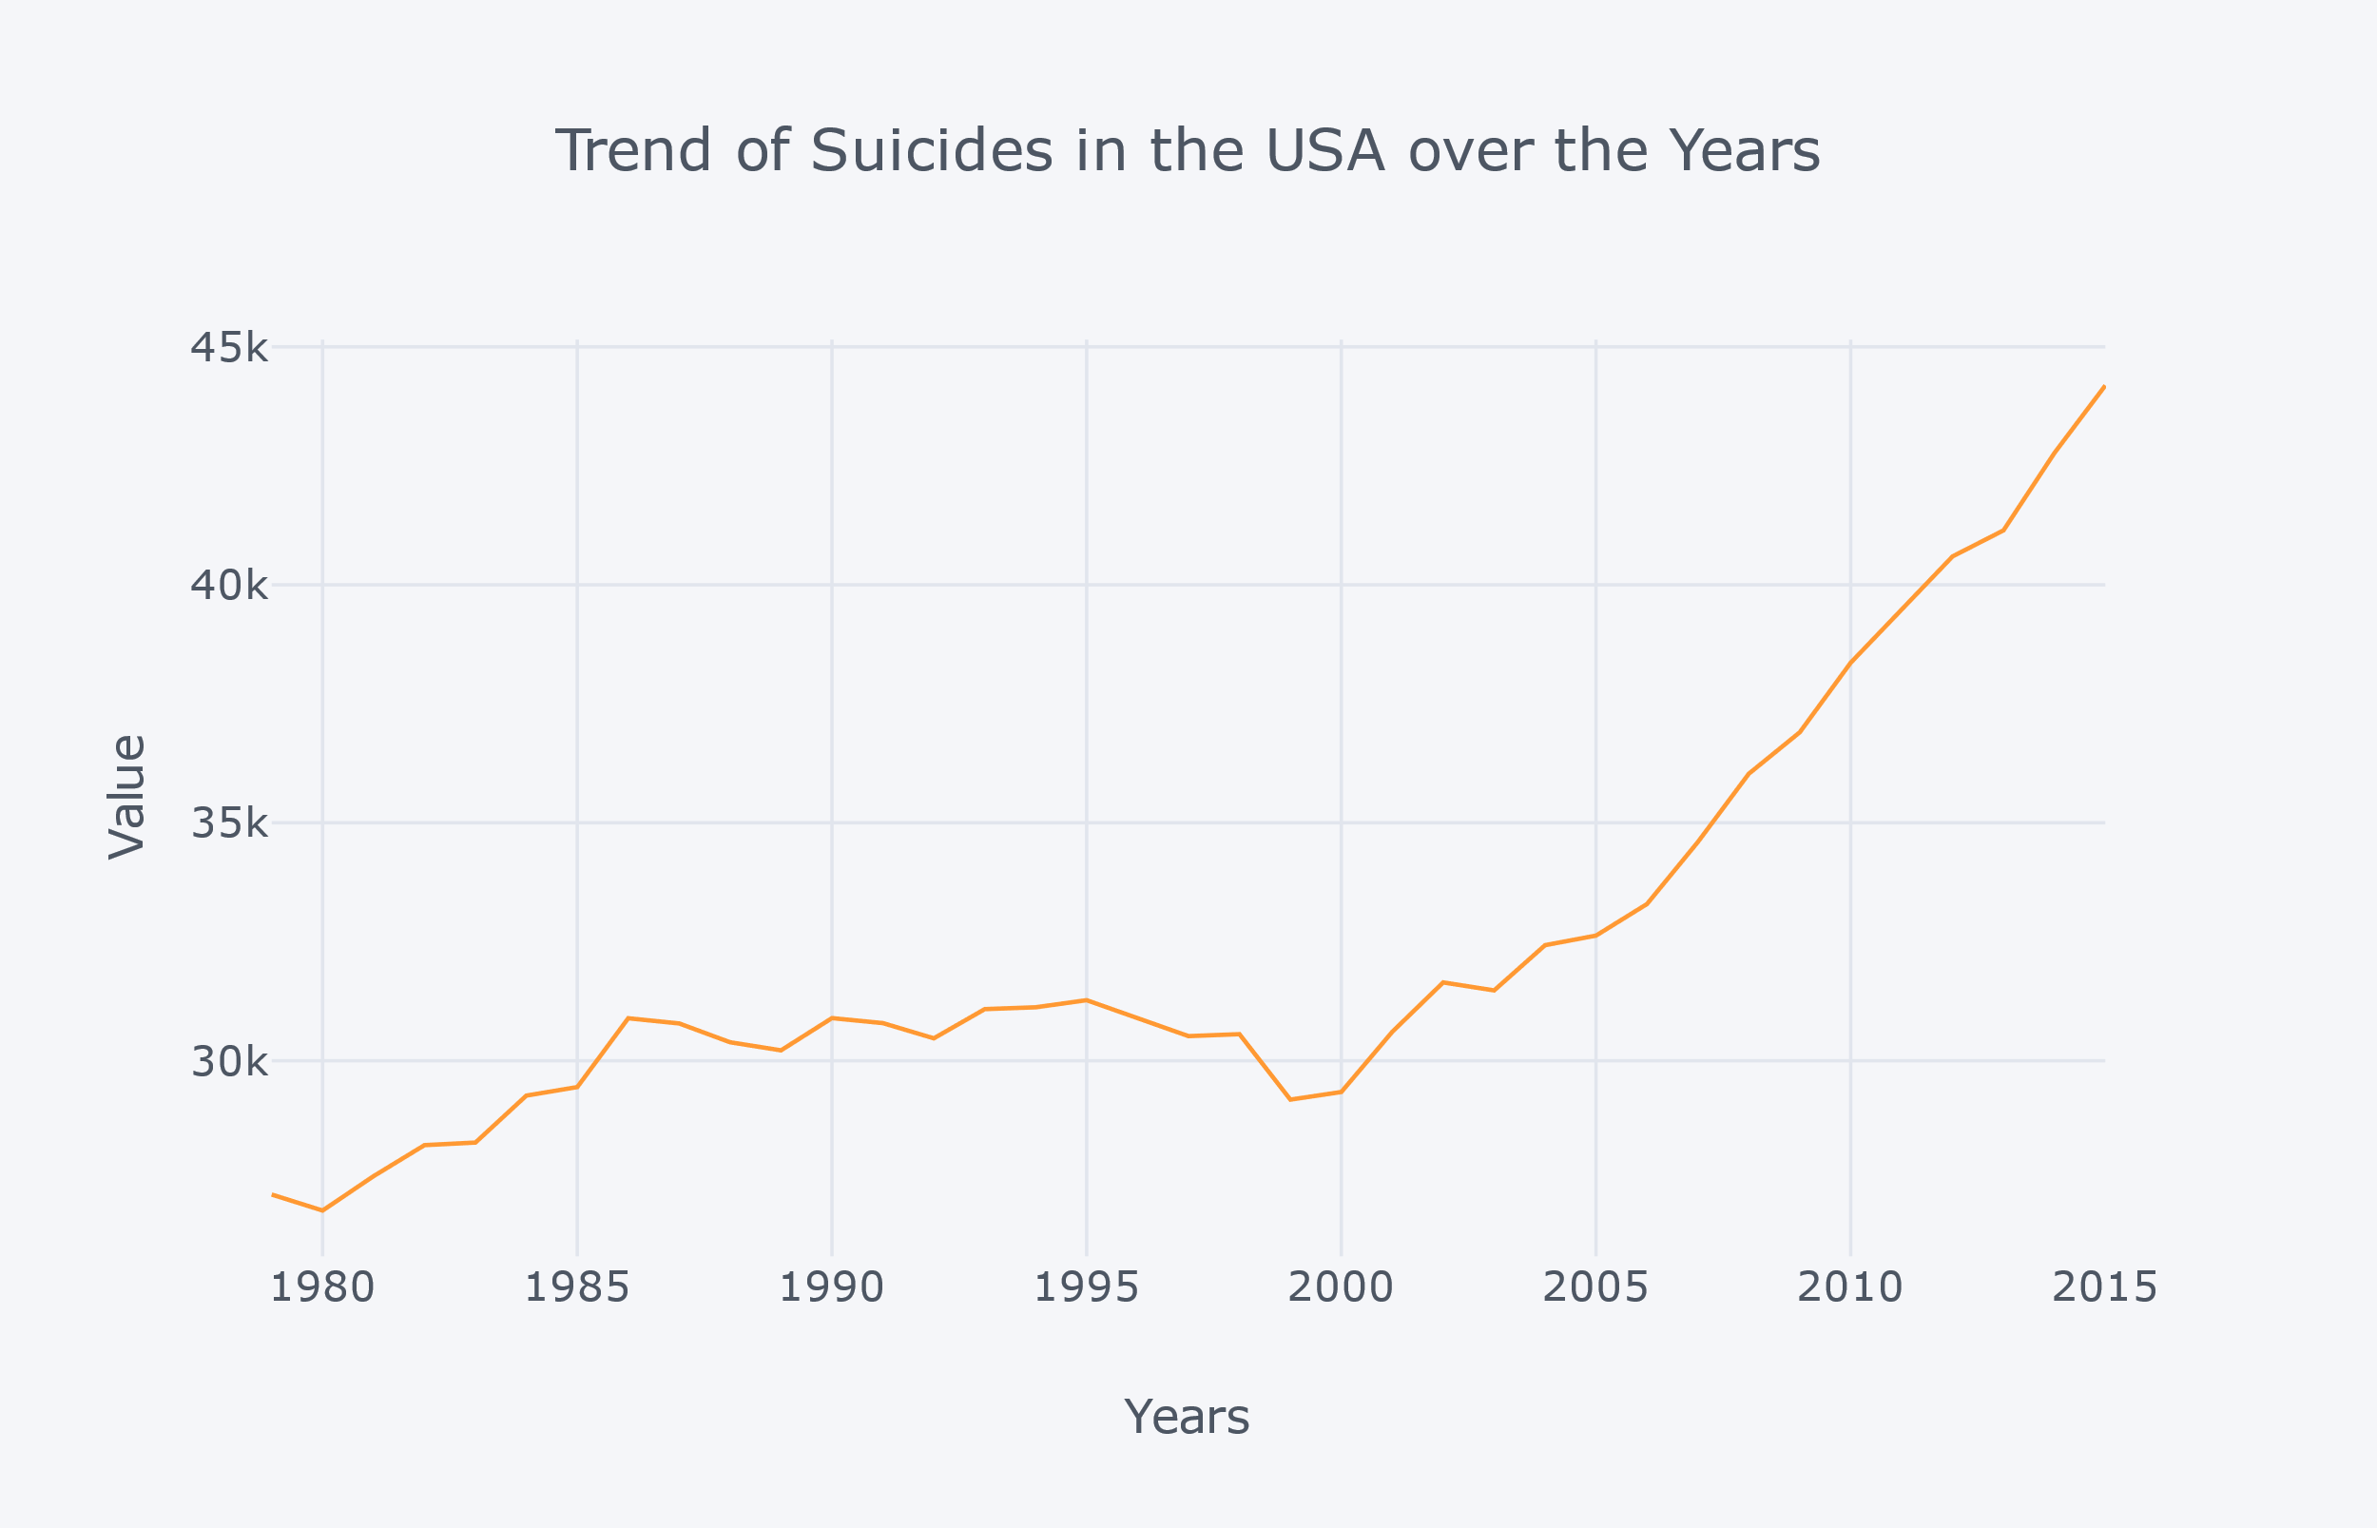

Form the graph we can see that the suicide rate is increasing in USA constantly with every year passing by. This is a matter of big concern for the people living in USA.

In 2015, 44,193 Americans died by their own hand. That was more than the number killed in motor vehicle accidents (37,757) and over twice the number who died through homicide (17,793).

There is evidence that rising suicide rates are associated with a weakening of the social norms regarding mutual aid and support.

[In one study](http://doi.org/10.1097/01.NMD.0000018958.17287.CF) on suicide in the U.S., the rising rates were closely linked with reductions in social welfare spending between 1960 and 1995. Social welfare expenditures include Medicaid, a medical assistance program for low income persons; Temporary Assistance for Needy Families, which replaced Aid to Families with Dependent Children; the Supplemental Security Income program for the blind, disabled and elderly; children’s services including adoption, foster care and day care; shelters; and funding of public hospitals for medical assistance other than Medicaid.

Forecasted Suicide Trend in USA:

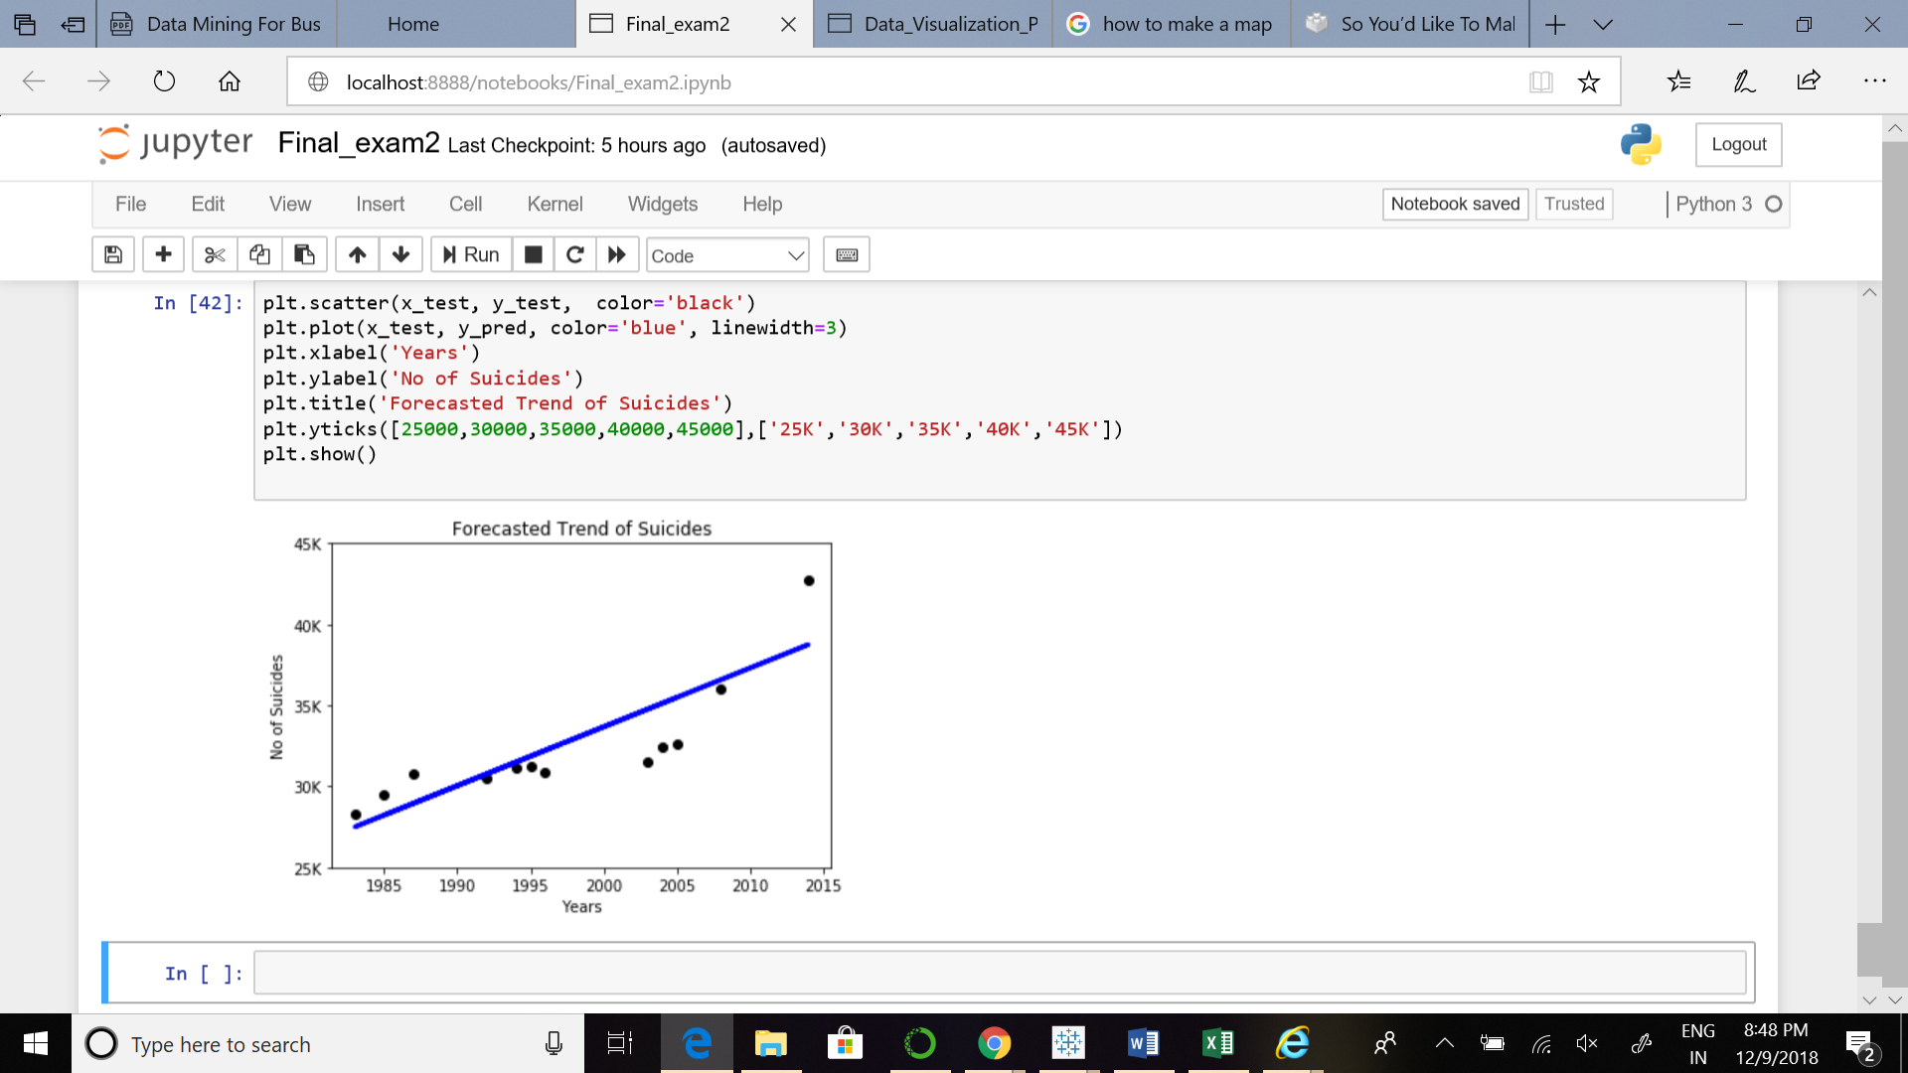

According to my linear regression model the suicide trend will increase in the coming future years if all the other variables are kept as it is. This is an alarming problem and government should interfere in it as soon as possible.

Conclusion:

I hope by now you got some idea about the suicide trend around the world and some causes of the suicides happening around us. According to my Report I think suicide is a major problem around the world and countries should take some sincere steps towards it especially USA where suicide rate is increasing every year and people in the age group 35-50 should be taken good care of. They are more vulnerable to commit suicide.

There should be stress relief camps and sessions government should restrict the purchase of lethal weapons with which people try to commit suicide. There should strong social norms regarding moral aid and support.